Dominic Drury

11/16/2023

CS340

4-1 Milestone: Create and Read in Python

Upload the Austin Animal Center (AAC) Outcomes data set into MongoDB

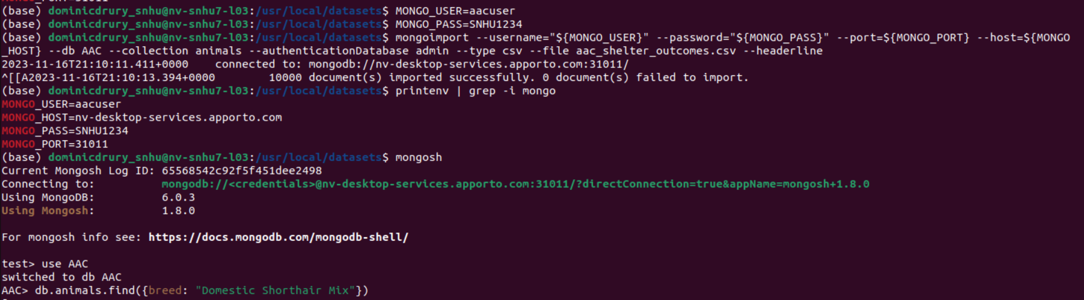

create a Python testing script in Jupyter Notebooks that imports your CRUD Python module to call and test the create and read instances of CRUD functionality

Code from testing notebook

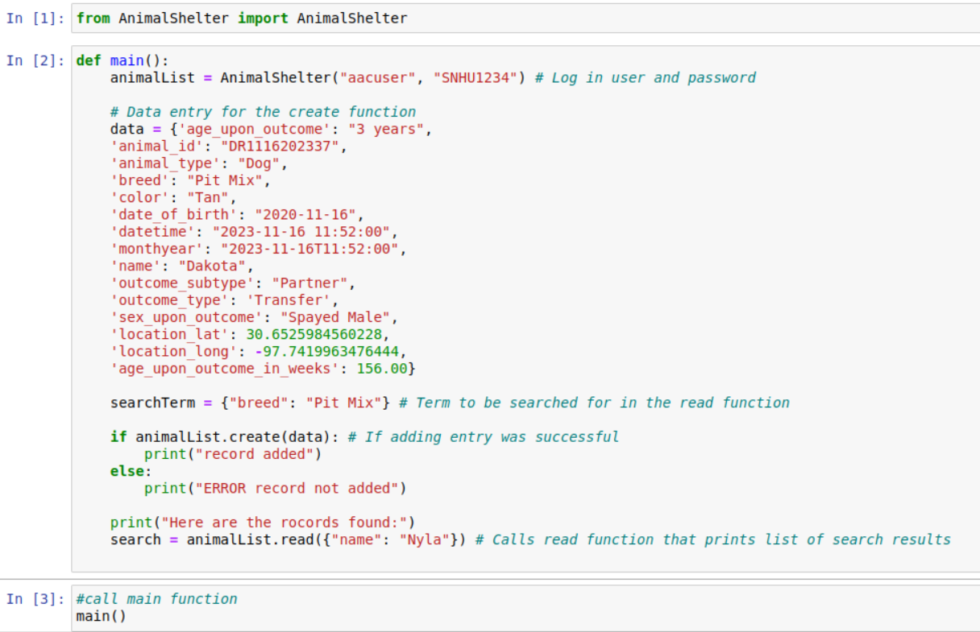

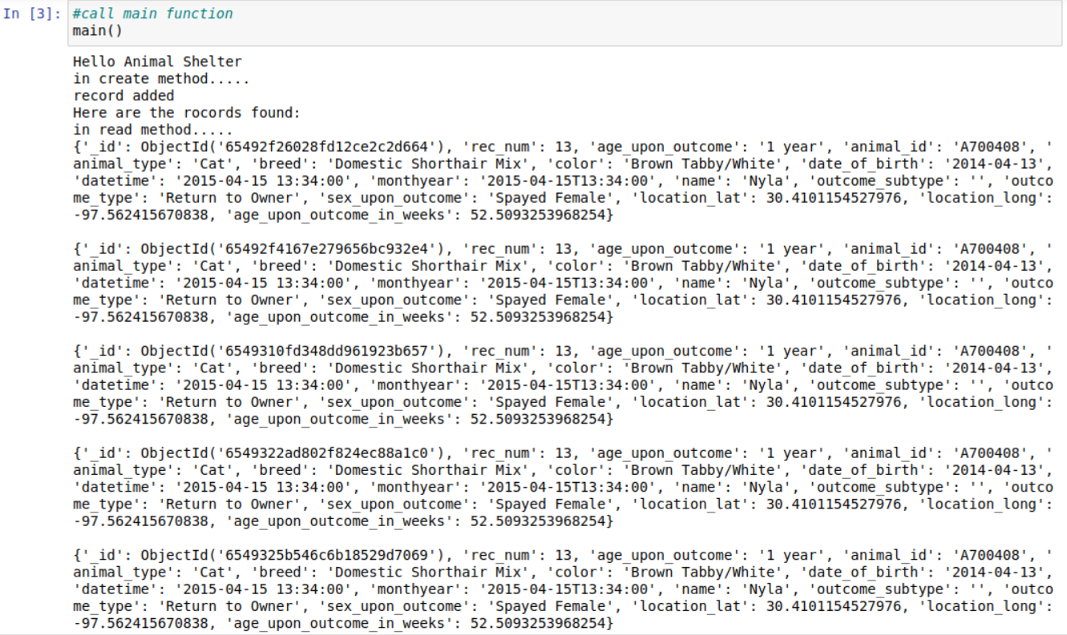

Code from Python Module

